**AO3** The student takes her own photographs and draws from them. The photos themselves are well taken, and she gets extra marks for these as recordings. She continues to work from them throughout the project.

**AO1/AO2** The student explores the work of 3 artists, creating her own interpretation of each one along with an analysis of the artist’s style and technique. She gives her opinion thoughtfully, with clear links to her own ideas and how she could take elements of each artist forward in her own way. She goes forward to combine elements of each artist in her experiments and outcomes.

**AO3** A variety of drawings at a high standard, demonstrating a high level of skill. Accurate and realistic, using a range of materials such as pen, pencil, pastels, charcoal, pencil crayons. Varied images – not repetitive.

What does an A Grade look like in GCSE Art?

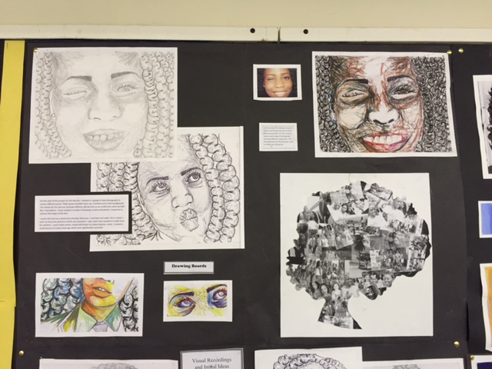 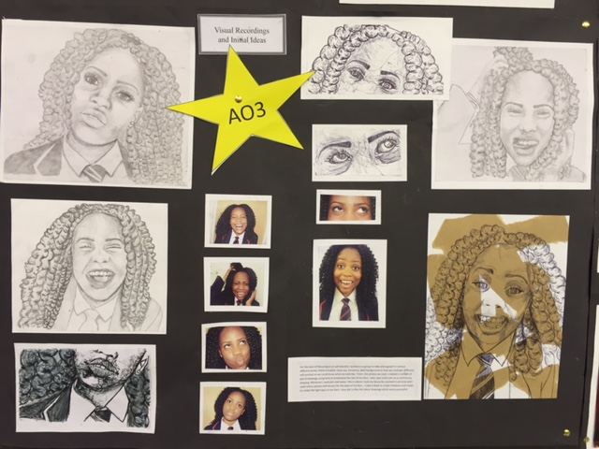 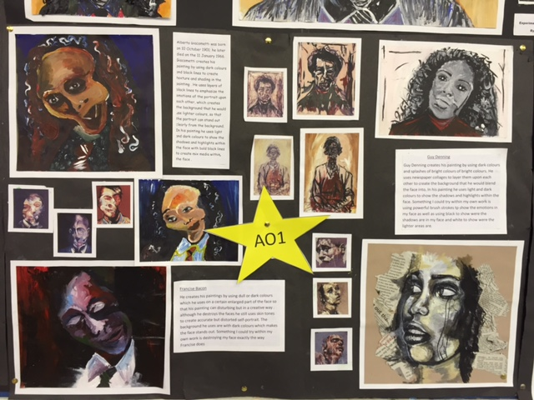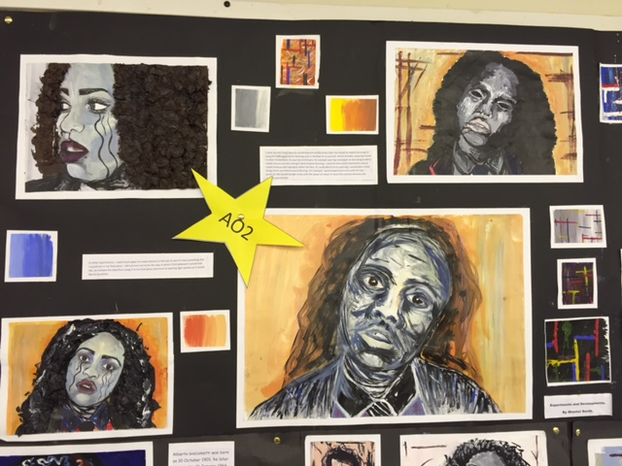 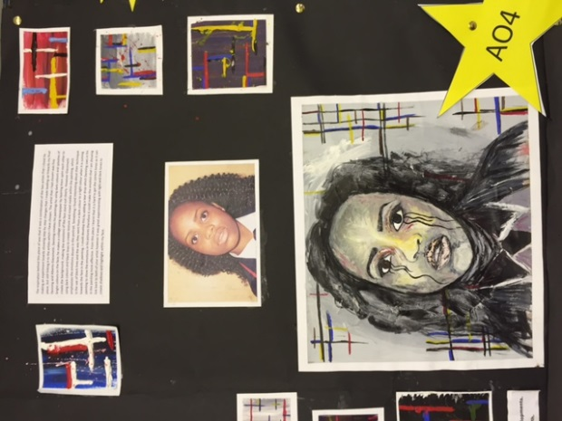 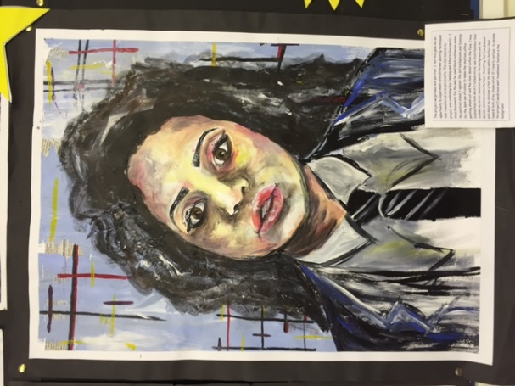

**AO4** The student’s final piece is the best of all her experiments. She combines the best of her experiments in one piece, taking a lot of time and care in order to ensure that it is finished to a really high standard. It is accompanied by a well written evaluation, reviewing the way the project developed and reflecting on the strengths and areas for development

**AO3** She did many of these drawings for homework as they take a long time to show a high level of skill.

**AO2/AO3** Experiments are based on earlier drawings and photographs.

**AO4** All work is presented neatly and clearly so it reads like a book from start to finish. This ensures that the examiner can fully understand the work when it is being marked, as well as clearly explaining the process she went through from start to finish.

**AO2/AO3** Experiments are varied and purposeful. You can clearly see the links to all three artists, both separately and combining elements from their work in one experiment. Experiments develop and show that she has reviewed her work in order to improve and move forwards. This is also explained through her annotations, which are well written, using technical language. She explores different techniques, different materials and varies her colour schemes, showing that she has tried out multiple ideas in order to get to the best possible final piece.

**AO3** The student takes some of her own photographs and draws from them, as well as drawing from the objects from life. She continues to reference these drawings throughout her project.

**AO1/AO2** The student explores the work of 2 artists, creating her own interpretation of each one along with an analysis of the artist’s style and technique. She gives her opinion thoughtfully, with clear links to her own ideas and how she could take elements of each artist forward in her own way. She goes forward to combine elements of each artist in her experiments and outcomes.

**AO3** A variety of drawings at a high standard, demonstrating a high level of skill. Accurate and realistic, using a range of materials such as pen, pencil, pastels, charcoal, pencil crayons. Varied sizes. Varied images – not repetitive.

What does an A Grade look like in GCSE Art?

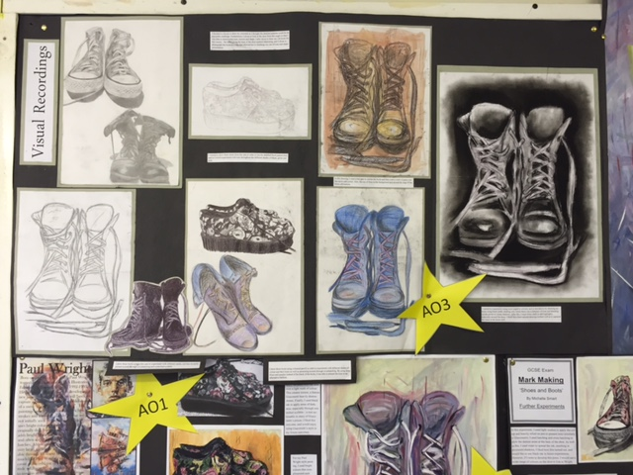 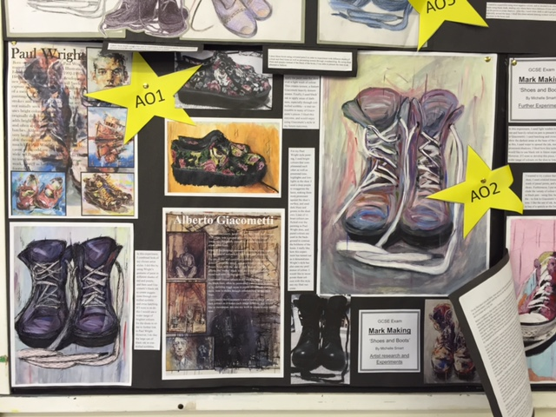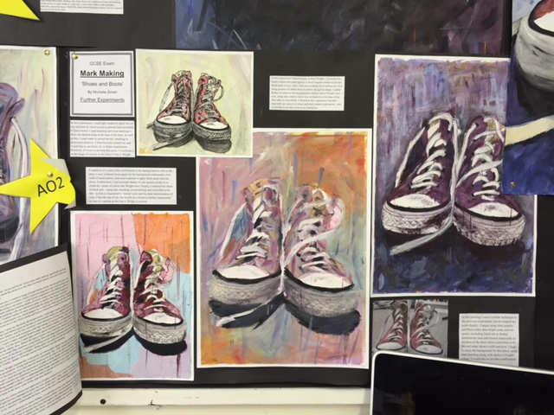 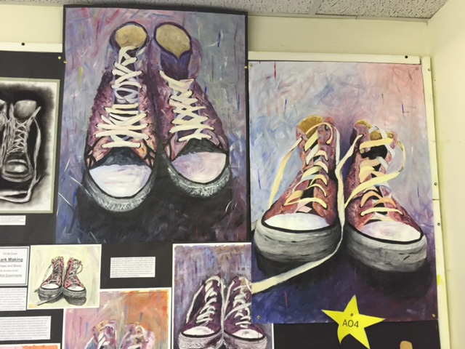 

**AO4** The student’s final piece is the best of all her experiments. She combines the best of her experiments in one piece, taking a lot of time and care in order to ensure that it is finished to a really high standard. It is accompanied by a well written evaluation, reviewing the way the project developed and reflecting on the strengths and areas for development.

**AO4** All work is presented neatly and clearly so it reads like a book from start to finish. This ensures that the examiner can fully understand the work when it is being marked, as well as clearly explaining the process she went through from start to finish.

**AO2/AO3** Experiments are based on earlier drawings and photographs.

**AO2/AO3** Experiments are varied and purposeful. You can clearly see the links to both artists, both separately and combining elements from their work in different experiments. Experiments develop and show that she has reviewed her work in order to improve and move forwards. This is also explained through her annotations, which are well written, using technical language. She explores different techniques, different materials and varies her colour schemes, showing that she has tried out multiple ideas in order to get to the best possible final piece.