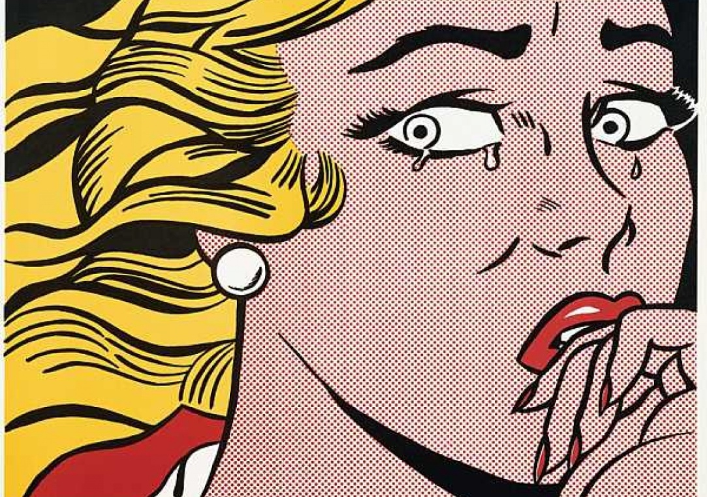
roy Lichtenstein (pop artist)
In the late 1940s, Lichtenstein exhibited his art in galleries nationwide, including in Cleveland and New York City. In the 1950s, he often took his artistic subjects from mythology and from American history and folklore, and he painted those subjects in styles that paid homage to earlier art, from the 18th century through modernism.
Lichtenstein began experimenting with different subjects and methods in the early 1960s, while he was teaching at Rutgers University. His newer work was both a commentary on American popular culture and a reaction to the recent success of Abstract Expressionist painting by artists like Jackson Pollock and Willem de Kooning. Instead of painting abstract, often subject-less canvases as Pollock and others had had done, Lichtenstein took his imagery directly from comic books and advertising. Rather than emphasize his painting process and his own inner, emotional life in his art, he mimicked his borrowed sources right down to an impersonal-looking stencil process that imitated the mechanical printing used for commercial art.
Lichtenstein's best-known work from this period is "Whaam!," which he painted in 1963, using a comic book panel from a 1962 issue of DC Comics' All-American Men of War as his inspiration. Other works of the 1960s featured cartoon characters like Mickey Mouse and Donald Duck and advertisements for food and household products. He created a large-scale mural of a laughing young woman (adapted from an image in a comic book) for the New York State Pavilion of the 1964 World's Fair in New York City.
Lichtenstein became known for his deadpan humor and his slyly subversive way of building a signature body of work from mass-reproduced images. By the mid-1960s, he was nationally known and recognized as a leader in the Pop Art movement that also included Andy Warhol, James Rosenquist and Claes Oldenburg. His art became increasingly popular with both collectors and influential art dealers like Leo Castelli, who showed Lichtenstein's work at his gallery for 30 years. Like much Pop Art, it provoked debate over ideas of originality, consumerism and the fine line between fine art and entertainment.

