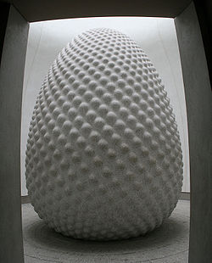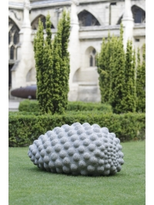
Peter Randall Page
Peter Randall-Page was born in the UK in 1954 and studied sculpture at Bath Academy of Art from 1973-1977.
During the past 25 years Peter Randall-Page has gained an international reputation through his sculpture drawings and prints. He has undertaken numerous large-scale commissions and exhibited widely. His work is held in public and private collections throughout the world including Japan, South Korea, Australia, USA, Turkey, Eire, Germany and the Netherlands. A selection of his public sculptures can be found in many urban and rural locations throughout the UK including London, Edinburgh, Manchester, Bristol, Oxford and Cambridge and his work is in the permanent collections of the Tate Gallery and the British Museum amongst others.
His practice has always been informed and inspired by the study natural phenomena and its subjective impact on our emotions.
In recent years his work has become increasingly concerned with the underlying principles determining growth and the forms it produces. In his words "geometry is the theme on which nature plays her infinite variations, and can be seen as a kind of pattern book on which the most complex and sophisticated structures are based."

