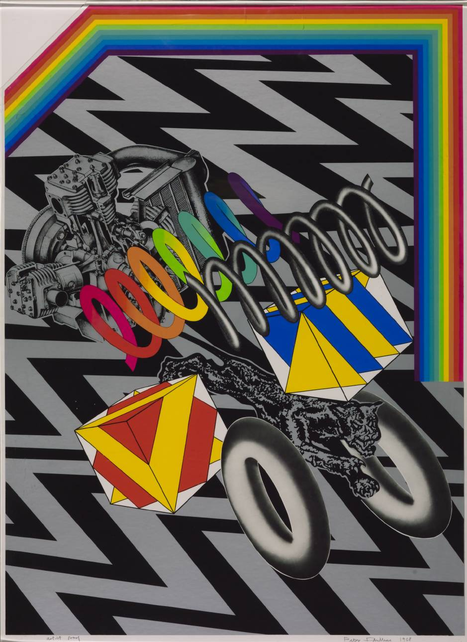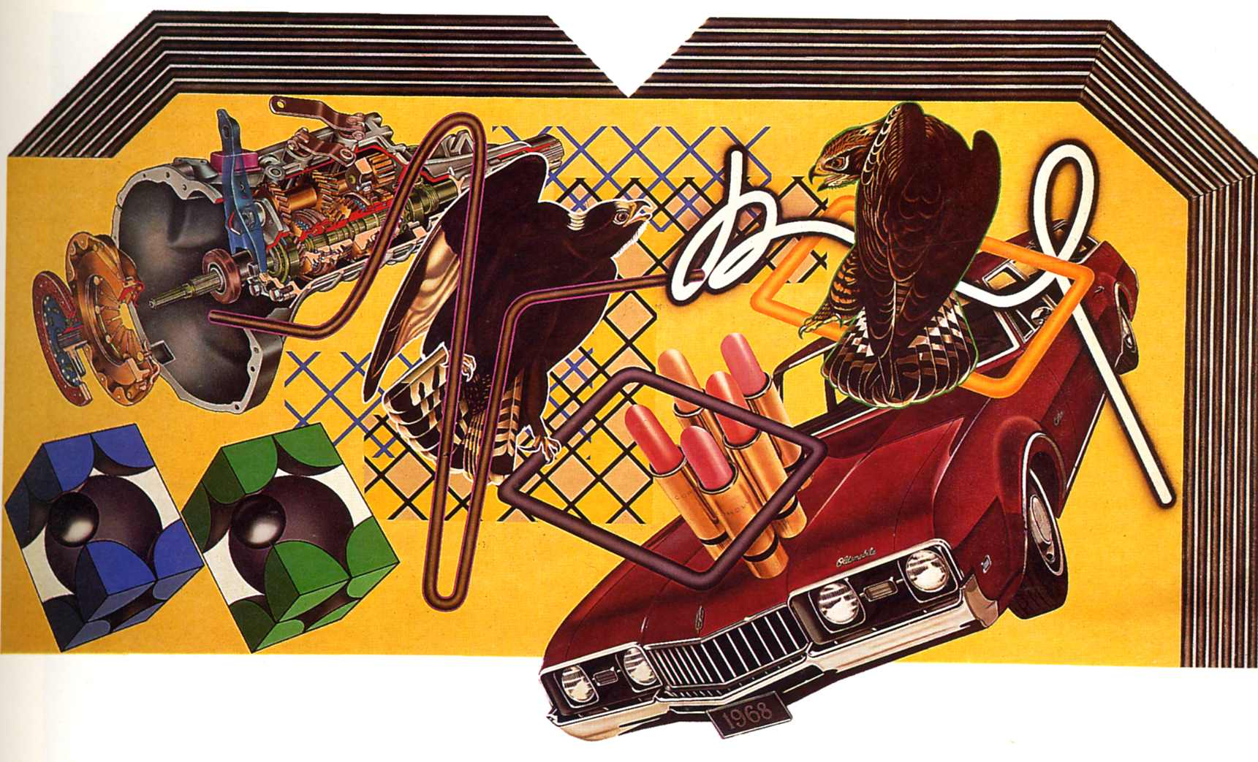
Peter Phillips
Peter Phillips (born 21 May 1939) is an English artist and pioneer of the Pop Art movement
In his early 1960s work, Phillips trusted his intuitions in marrying the formal grandeur and ambitious scale of Abstract Expressionism with his passion for the trapping of youth culture, with all its associated glamour, energy; he borrowed his imagery and hard-edged formal patterns from game boards, the funfair, pin-ups, comic books and other popular sources.
During the 1970s he painted a series of Compositions and Select-O-Mat paintings, populated with predatory birds, molecular structures from the pages of ‘Scientific American’, motor engines and machine parts

