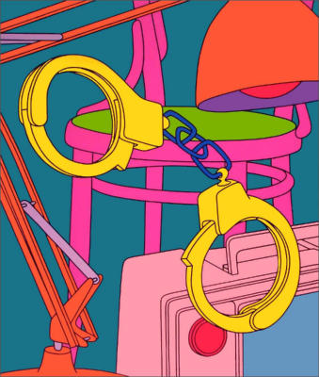
Michael Craig-Martin RA (born Dublin, 28 August 1941) is a contemporary conceptual artist and painter
In 1966 Craig-Martin moved to England to teach, and he eventually taught from 1973 at Goldsmiths College in London, where he remained a powerful influence on students through the 1980s and 1990s. His early work made deliberate reference to the American artists he most admired, such as Donald Judd, Jasper Johns and Robert Morris. Although he was particularly affected by Minimalism and used ordinary household materials in his sculptures, he played against the logic of his sources; in Four Identical Boxes with Lids Reversed (painted blockboard, 1969; London, Tate), for example, he created a curious progression by slicing into four identical boxes at different angles and then exchanging their halves.
Craig-Martin continued working in various forms, always maintaining an elegant restraint and conceptual clarity. During the 1990s the focus of his work shifted decisively to painting, with the same range of boldly outlined motifs and luridly vivid colour schemes in unexpected (and at times apparently arbitrary) combinations applied both to works on canvas, such as Knowing (1996; London, Tate) and to increasingly complex installations of wall paintings. For his one-man exhibition at the Kunstverein Hannover in 1998, Craig-Martin transformed the galleries into a series of environments of luscious colour, onto which he painted his characteristic motifs of tables, chairs and stepladders and also hung paintings, reliefs and wall-mounted sculptures.
YOUR OPINION
HOW HIS WORK COULD GIVE YOU IDEAS.

