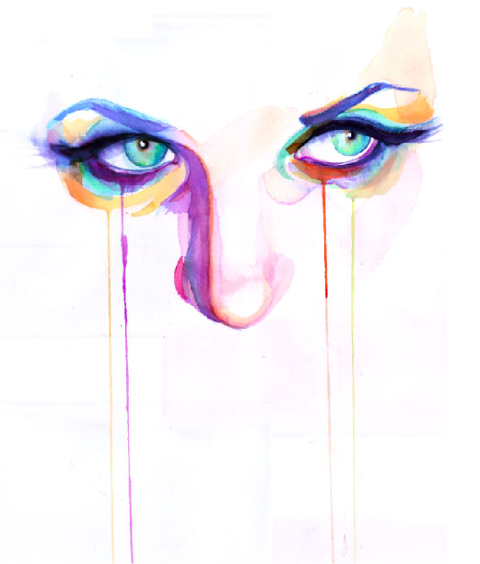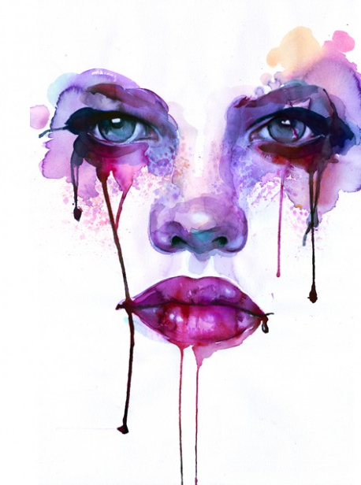

MARION BOLOGNESI INTERVIEW
I work full time as a designer & my personal artwork is really what I come home to. That leaves me with a pretty art heavy schedule. I recently started blogging as well, it’s seriously addictive & has added a whole new element to my daily art fix.
Most days I sketch at work- snoop artists & fashion online- maybe drop off a few prints at the post office and I get home and do a little painting- I’m trying to get myself to one new watercolor a week. I’ll get there by summer!

My work is very personal. It’s not as if I don’t enjoy the attention I’ve gotten for it. But, at the end of the day, it’s really something that I do for myself.
When I was in college, I spent a lot of time drawing & painting as an illustrator for hypothetical assignments to the point where I really felt burnt out as a painter. During that time, I realized, there’s a lot of subject matter that I’m really not interested in painting.
Since that time I’ve become almost hyper focused in faces and facial expressions. It’s the subject matter that I love & really interests me, I don’t know if I’ll ever get sick of it. I also have a very close relationship with watercolor as a medium.
It’s very easy for me to lose myself in a painting. I definitely want to continue with these focuses and try to push myself to find new paths to explore expression, watercolor and portraiture.
Who are some of your favorite contemporary artists? (writers, programmers, painters, architects, philosophers)
Peter Calleson, Theo Jansen & JS Mildenberg
- See more at: http://pagestopixels.com/?p=1877#sthash.HMWVzmP4.dpuf

