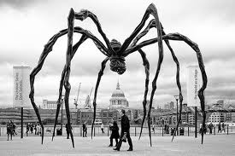

Maman (1999) is a sculpture by the artist Louise Bourgeois. The sculpture, which resembles a spider, is amongst the world's largest and most impressive, measuring over 30 ft high and over 33 ft wide, with a sac containing 26 marble eggs. Its abdomen and thorax are made up of ribbed bronze.^{[1]} The title is the familiar French word for Mother.
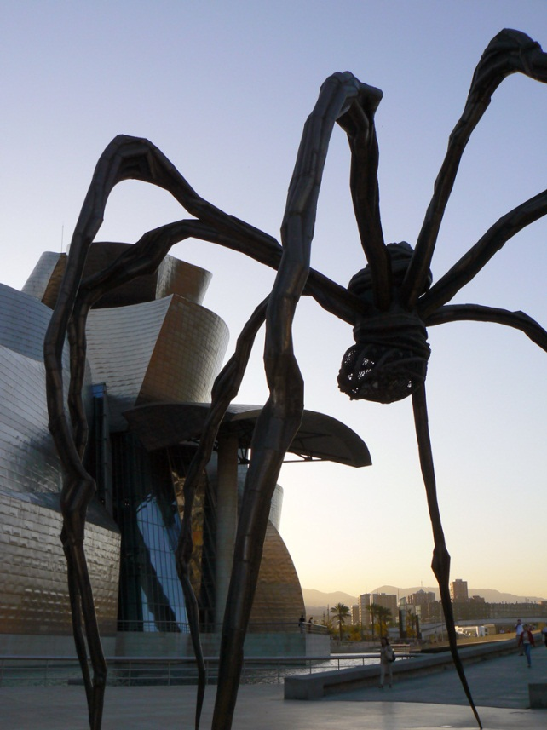
The sculpture picks up the theme of the arachnid that Bourgeois had first contemplated in a small ink and charcoal drawing in 1947.^{[1]} It alludes to the strength of Bourgeois' mother, with metaphors of spinning, weaving, nurture and protection.^{[2]} Her mother Josephine was a woman who repaired tapestries in her father's textile restoration workshop in Paris.^{[1]} Bourgeois lost her mother at the age of twenty-one. A few days afterwards, in front of her father who did not seem to take his daughter’s despair seriously, she threw herself into the Bièvre River; he swam to her rescue.^{[3]}

Louise Joséphine Bourgeois (French: [lwiz buʁʒwa]; 25 December 1911 – 31 May 2010),^{[1]} was a renowned French-American artist and sculptor, best known for her contributions to both modern and contemporary art, and for her spider structures, titled Maman, which resulted in her being nicknamed the Spiderwoman.^{[2]} In 2011 one of her Spider works sold for $10.7 million, a new record price for the artist at auction,^{[3]} and the highest price paid for a work by a woman artist.^{[4]}

