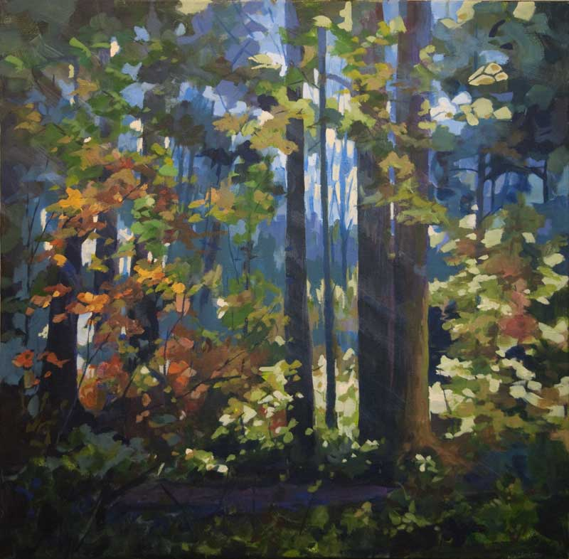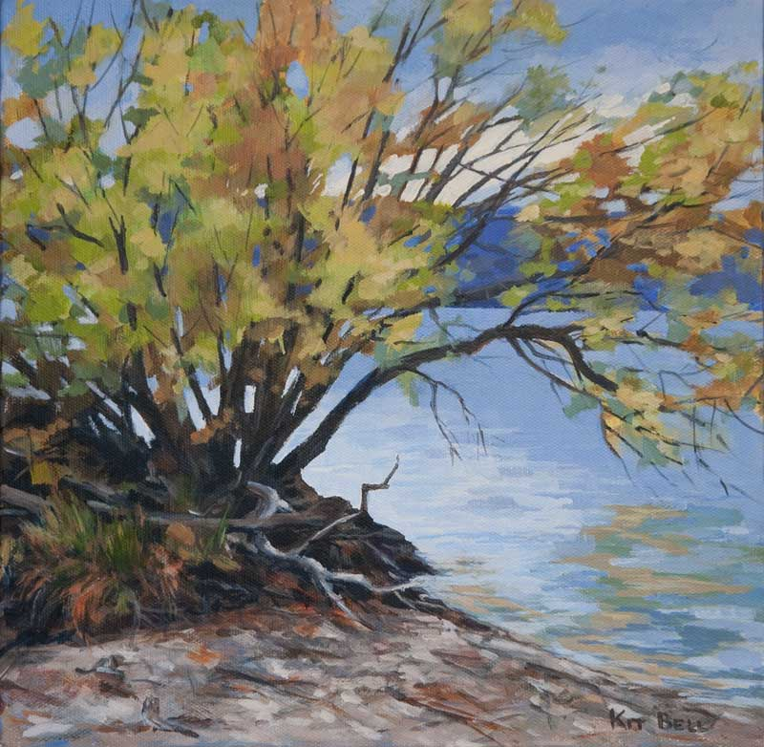
Kit Bell
This artist builds up layers of paint, working from dark and dull colours as base colours, then adding more and more light areas to create depth and tone within her work. She uses thick brush strokes to suggest leaves and texture.

