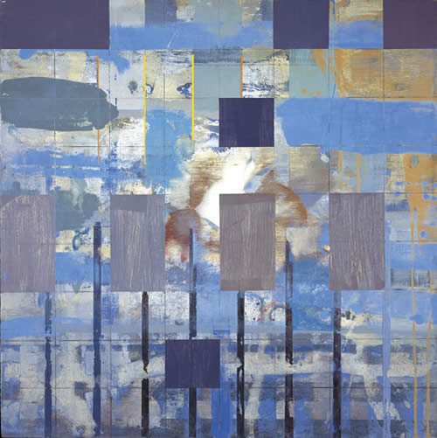
Kevin laycock
The artist has been exploring the parallels between structural abstraction in painting and musical theory in relation to colour and form. This has led to a group of complex but individually radiant paintings which have already had wide acclaim in a current UK museum tour (including Ferens Art Gallery, Hull).
The idea that there can be a relationship between non-figurative non-narrative music and abstract art is hardly a new consideration, Laycock's initiative is the creation of intensely considered and rigorously executed colour-harmonic paintings, governed by systems much like those followed by composers.
With an authoritative and erudite system all of his own, Kevin Laycock makes a newly significant contribution to the canon of abstract art in this country.

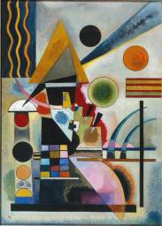
Wassily Kandinsky 1866-1944
Russian-born painterMade paintings and woodcuts inspired by Russian folk art and fairy tales, and also landscape studies painted directly from nature. Developed rich, contrasts of colour, then began and composed paintings with abstract colours and shapes. He then began to work with precise, geometrical shapes.
Abstract artist
Made art to music using shapes and colour to represent it.

