Joseph Cornell
American artist – born 1903, Died 1973
One of the pioneers and most celebrated artists of assemblage. Influenced by the Surrealists, he was also an experimental filmmaker.
By collecting and carefully juxtaposing found objects in small, glass-front boxes, Cornell created visual poems in which surface, form, texture, and light play together. Using things we can see, Cornell made boxes about things we cannot see: ideas, memories, fantasies, and dreams.
He was a kind of magician, turning everyday objects into mysterious treasures. In Homage to the Romantic Ballet, plastic ice cubes become jewels when set in a velvet-lined box, souvenirs of a famous ballerina's midnight performance on the frozen Russian steppe. A small glass jar filled with colored sand is transformed into powdered gold from a Mayan temple, carefully preserved in Cornell's Museum.
A symbolist, Cornell used the found materials that inhabit his boxes—paper birds, clay pipes, clock springs, balls, and rings—to hint at abstract ideas. A metal spring from a discarded wind-up clock may evoke the passage of time; a ball might represent a planet or the luck associated with playing a game. Although his constructions are enveloped in nostalgia—the longing for something that happened long ago and far away—their appearance is thoroughly modern.

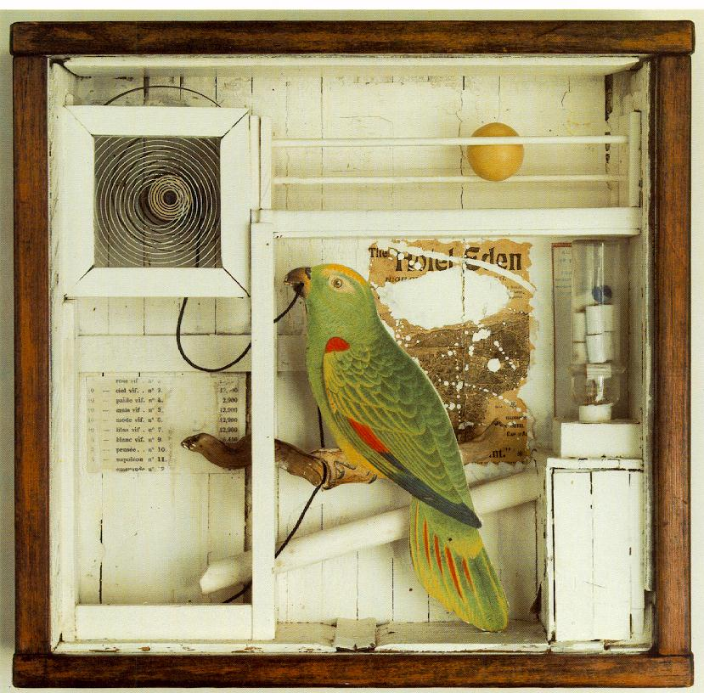

Also add: your own analysis of the work/idea/how it is made etc, your opinion and link it to your ideas/how it could inspire you.

