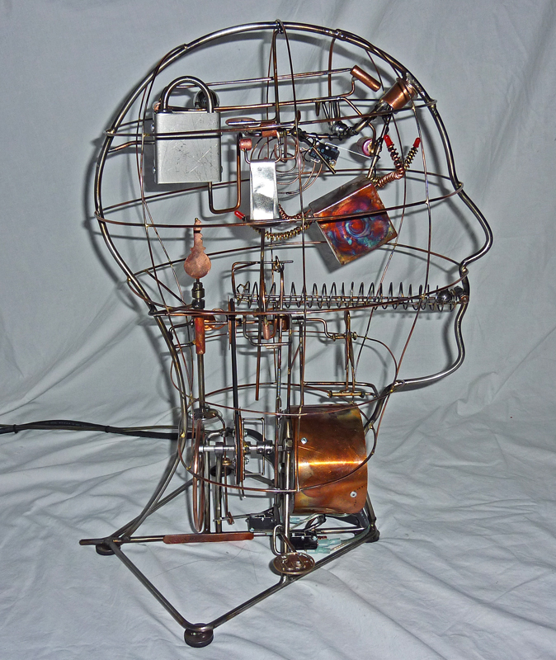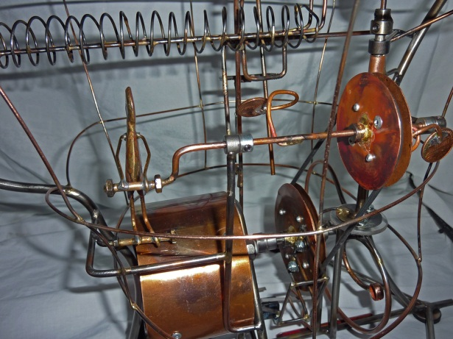
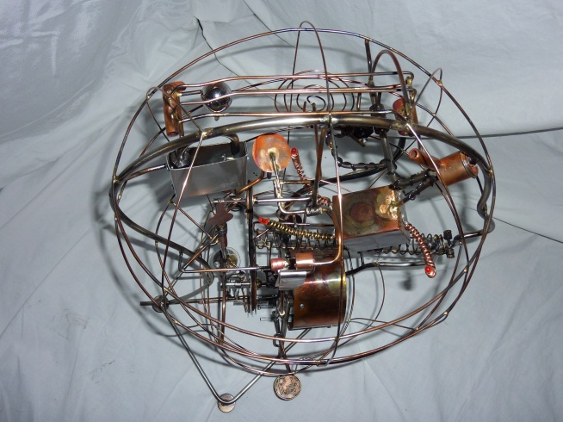
BRAIN on DRUGS
- The "Brain on Drugs" was a special commission for a physician specializing in drug addiction. The sculpture depicts an artistic interpretation of what occurs in a patient's brain under the influence of a drug. When the sculpture is activated, it shows a "pill" (small steel ball) rolling from the mouth. The active form of the drug in the brain (represented by a key) interacts when the brains receptors (a lock) activates the brains reward system. As the lock is opened, it sends signalsto other areas of the brain (via a rolling ball) and causes rewarding impulses
(flashing lights and bell)
.The Brain on Drugs sculpture utilizes a remote electronic timing module, micro
switches, and DC circuit boards (for LED lighting) in addition to cams, levers, ramps,
balls etc., which enables the proper start/stop and sequencing of the sculpture
movements.
The operation of the Brain Sculpture works
in this way:
An observer presses the start lever and the “drug” ball rolls from the mouth into the
head. The “Little Man” inside the brain takes over and the “opioid” key rises to open the
“opioid receptor” lock. The “brain” is activated and a ball rolls energizing LED
lights while a bell drops in front of the bell hammer and the bell sounds twice. The key
drops out of the receptor lock, but the “little man” inside the brain continues with the
desire for more drug and begins the opioid/receptor cycle again. Two pennies
rotate as a reminder of the brains value on drugs--about two cents. The cycle repeats
five times then automatically stops, awaiting another start activation by an observe

