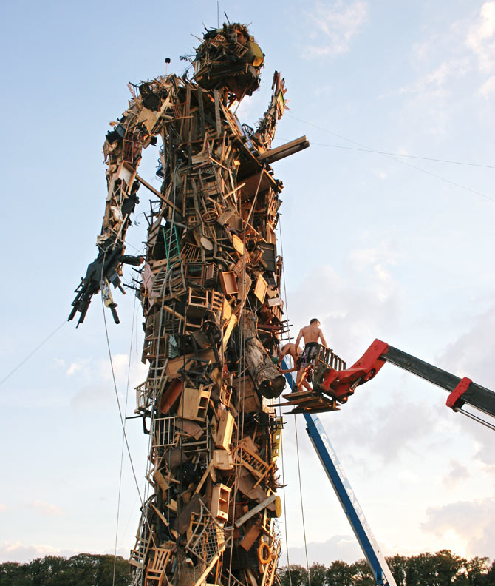
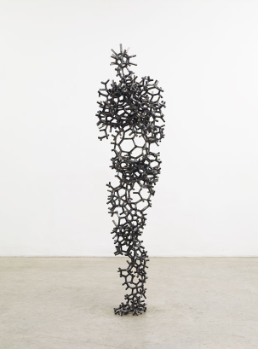
Antony Gormley is widely acclaimed for his sculptures, installations and public artworks that investigate the relationship of the human body to space. His work has developed the potential opened up by sculpture in the 1970s through a critical engagement with both his own body and those of others in a way that confronts fundamental questions of where human being stands in relation to nature and the cosmos. Gormley continually tries to identify the space of art as a place of becoming in which new behaviours, thoughts and feelings can arise. Gormley's work has been widely exhibited throughout the UK and internationally with exhibitions.
Include some of the above information, then the following for the higher marks:
- Your observations of the artist’s use of colour, materials, techniques etc.

- Your opinion of the work

- How they could inspire you

