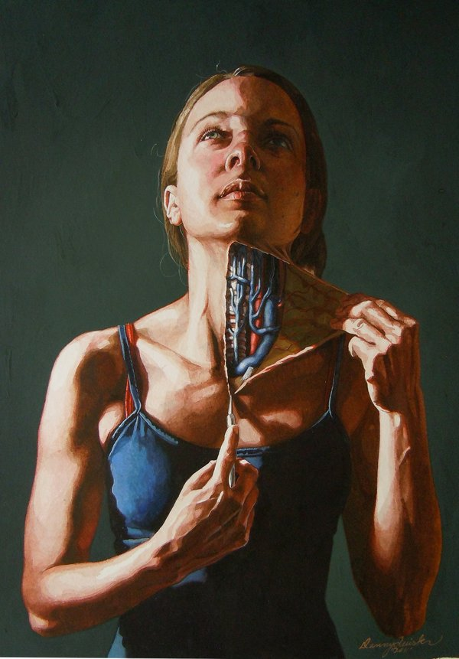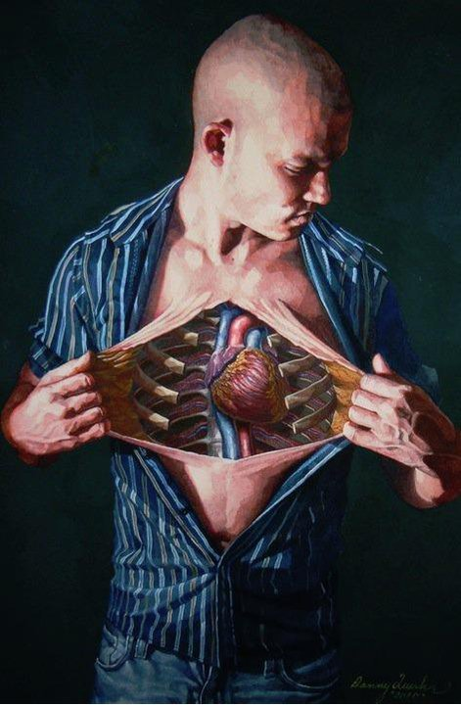
Anatomical Self-Dissections by Danny Quirk
Beautiful yet somewhat chilling watercolor paintings by artist Danny Quirk who lives and works out of Springfield, Massachusetts.
On his website, he said:
“My anatomical works combine classic poses, in dramatic lighting, with a very contemporary twist… illustrating what’s underneath the skin, and the portrayed figure dissects a region of their body to show the structures that lay beneath.”

