Your name here:
Design a T-shirt cover lesson: 3/7/15
Your challenge for the lesson is to research, brainstorm and design a t-shirt that you could make using the techniques that we have learnt this term.
Task 1: List all of the textiles techniques that we have learnt this term.

Task 2: Who would your t-shirt be designed for?
Male or female:
Age range:
Style:

Task 3: Find a range of images that could give you ideas for your t-shirt design. What style would you want it to be? Sporty, Fashionable, Urban, Chic… do some research then copy and paste your favourite 5 designs below.

Print this sheet when you have finished task 3. Complete task 4 by hand, preferably in pencil.
Task 4: Draw 3 different versions of your t-shirt designs (front and back). Try to be creative with the image/pattern you include. Refer to the internet if you get stuck for ideas.
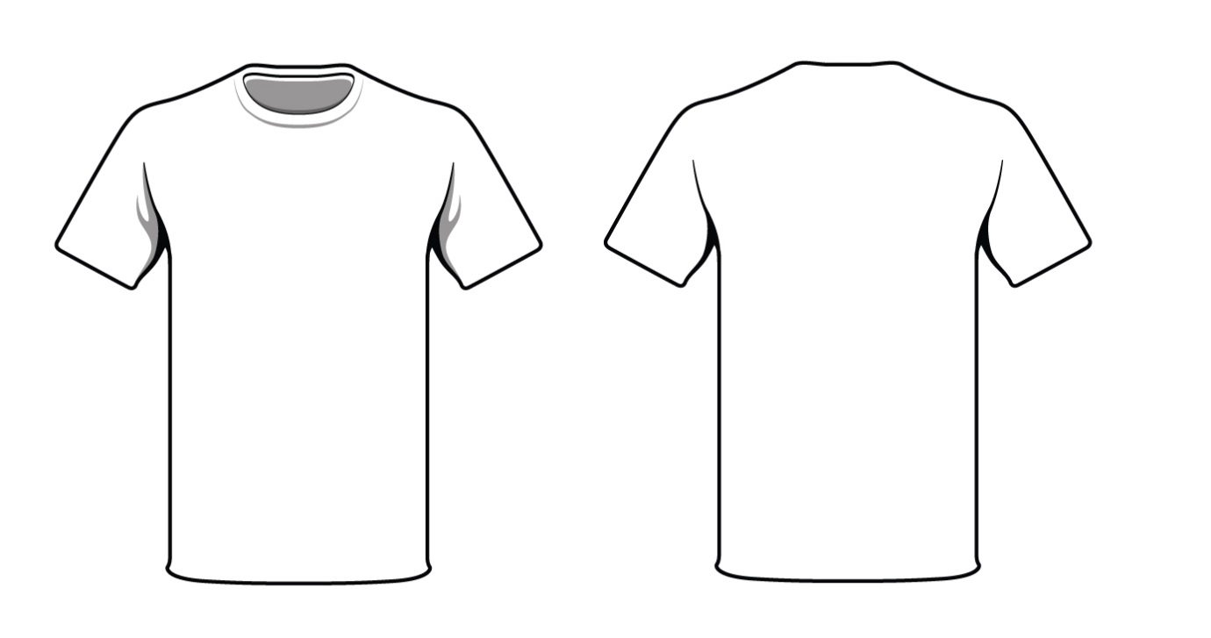
Decide which is your best design – ask a friend to help you if you’re not sure. For this design only, add labels with arrows to different parts of your design to show the different textiles techniques that you would use to create your t-shirt. How could you apply what you have learnt this term creatively?

