Christo and Jean Claude
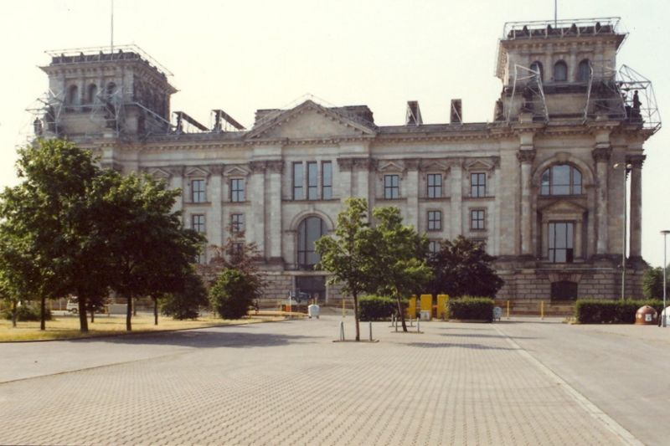
After a struggle spanning the seventies, eighties and nineties, the wrapping of the Reichstag was completed on June 24, 1995 by a work force of 90 professional climbers and 120 installation workers. The Reichstag remained wrapped for 14 days and all materials were recycled.
1,076,390 square feet (100,000 square meters) of thick woven polypropylene fabric with an aluminum surface and 9.7 miles (15.6 kilometers) of blue polypropylene rope, diameter 1.26 inch (3.2 centimeters), were used for the wrapping of the Reichstag. The façades, the towers and the roof were covered by 70 tailor-made fabric panels, twice as much fabric as the surface of the building.
The work of art was entirely financed by the artists, as in all previous projects, through the sale of preparatory studies, drawings, collages, scale models as well as early works and original lithographs. The artists do not accept sponsorship of any kind.
The Wrapped Reichstag represents not only 24 years of efforts in the lives of the artists but also years of team work by its leading members Michael S. Cullen, Wolfgang and Sylvia Volz, and Roland Specker.
The Reichstag stands up in an open, strangely metaphysical area. The building has experienced its own continuous changes and perturbations: built in 1894, burned in 1933, almost destroyed in 1945, it was restored in the sixties, but the Reichstag always remained the symbol of Democracy.
Throughout the history of art, the use of fabric has been a fascination for artists. From the most ancient times to the present, fabric forming folds, pleats and draperies is a significant part of paintings, frescoes, reliefs and sculptures made of wood, stone and bronze. The use of fabric on the Reichstag follows the classical tradition. Fabric, like clothing or skin, is fragile; it translates the unique quality of impermanence.
For a period of two weeks, the richness of the silvery fabric, shaped by the blue ropes, created a sumptuous flow of vertical folds highlighting the features and proportions of the imposing structure, revealing the essence of the Reichstag.

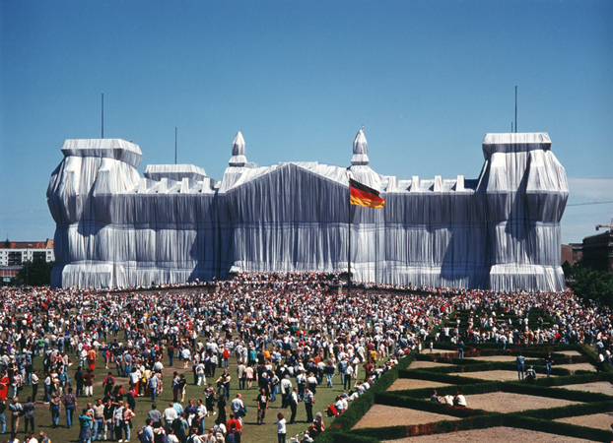
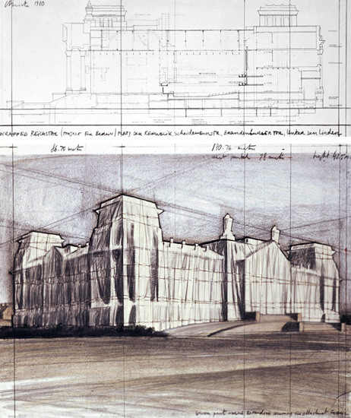

To his critics Christo replies, "I am an artist, and I have to have courage ... Do you know that I don't have any artworks that exist? They all go away when they're finished. Only the preparatory drawings, and collages are left, giving my works an almost legendary character. I think it takes much greater courage to create things to be gone than to create things that will remain."^{[4]}

