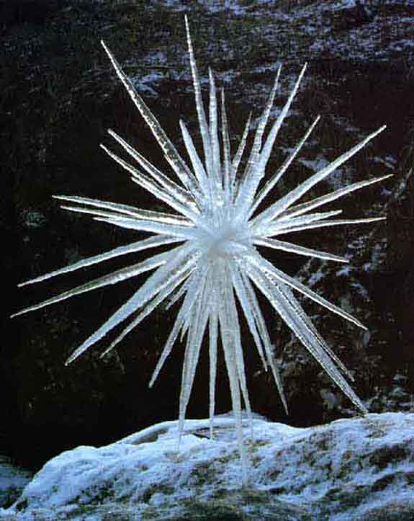
Andy Goldsworthy

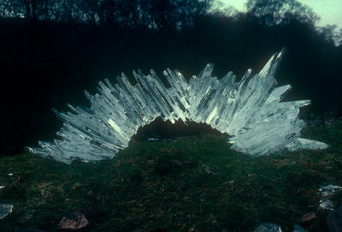

Andy Goldsworthy is a brilliant British artist who collaborates with nature to make his creations. This type of art is called Land Art.

Goldsworthy regards his creations as temporary as they don’t last long outside due to the environment and weather. He photographs each piece once right after he makes it. His goal is to understand nature by directly participating in nature as intimately as he can. He generally works with whatever comes to hand: twigs, leaves, stones, snow and ice, reeds and thorns.

In my opinion, Andy Goldsworthy’s work is interesting, particularly the techniques he has used and natural materials and the way they are put together to create a sculpture.

His work could inspire me by looking at the shapes and textures of his ice sculptures and applying them to my own work which although it is based on crystals, could look similar and would layer similar shapes.

