William Morris
You looked at this artist for pattern inspiration in the middle of the flower.
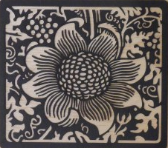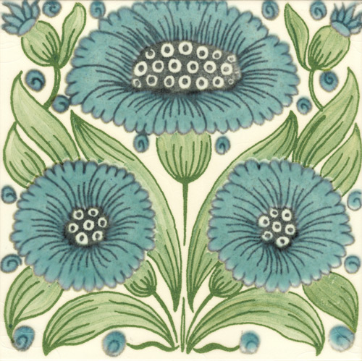
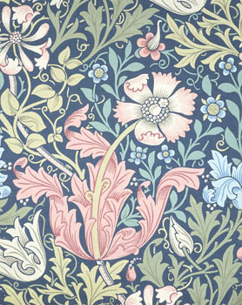
comment on the fact that you like the way he uses circles in the centre of the flowers, but that you would use more texture and tone to make the idea your own.

