Van gogh sunflowers
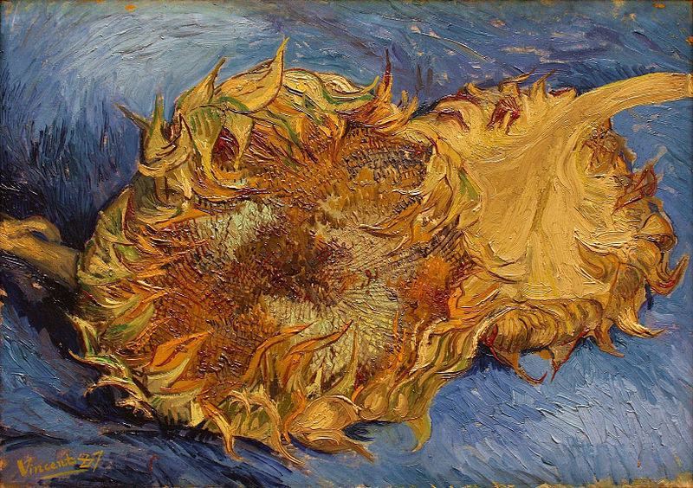
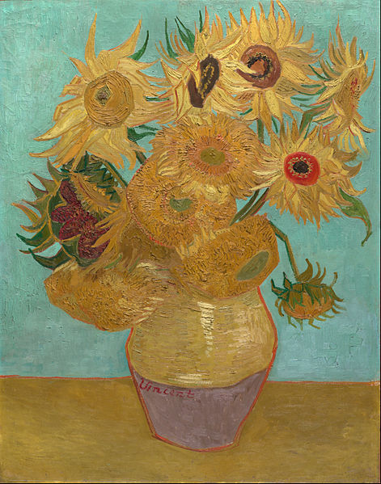
This is one of four paintings of sunflowers dating from August and September 1888. Van Gogh intended to decorate Gauguin's room with these paintings in the so-called Yellow House that he rented in Arles in the South of France. He and Gauguin worked there together between October and December 1888.
Van Gogh wrote to his brother Theo in August 1888, 'I am hard at it, painting with the enthusiasm of a Marseillais eating bouillabaisse, which won't surprise you when you know that what I'm at is the painting of some sunflowers. If I carry out this idea there will be a dozen panels. So the whole thing will be a symphony in blue and yellow. I am working at it every morning from sunrise on, for the flowers fade so quickly. I am now on the fourth picture of sunflowers. This fourth one is a bunch of 14 flowers ... it gives a singular effect.'
The dying flowers are built up with thick brushstrokes (impasto). The impasto evokes the texture of the seed-heads. Van Gogh produced a replica of this painting in January 1889, and perhaps another one later in the year. The various versions and replicas remain much debated among Van Gogh scholars

