Images from 'A Humument' by Tom Phillips
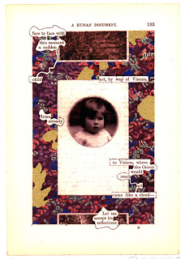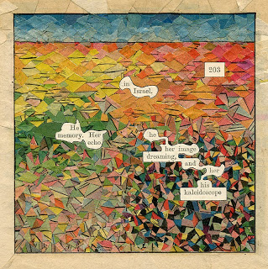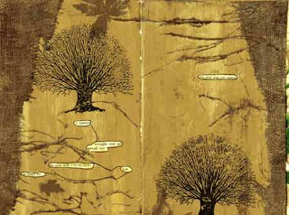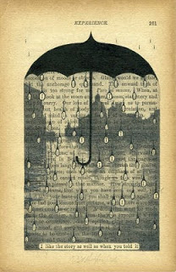
http://humument.com/
In 1966 artist Tom Phillips set himself a task: to find a second-hand book for threepence and alter every page by painting, collage and cut-up techniques to create an entirely new version. He found his threepenny novel in a junkshop on Peckham Rye, South London. This was an 1892 Victorian obscurity titled A Human Document by W.H Mallock and he titled his altered book A Humument. The first version of all 367 treated pages was published in 1973 since when there have been four revised editions. A Humument is now one of the best known and loved of all 20th Century artist's books and is regarded as a seminal classic of postmodern art.

