Shepard Fairey

Frank Shepard Fairey (born February 15, 1970) is an American contemporary graphic designer and illustrator who emerged from the skateboarding^{[1]} scene
Fairey’s work combines elements of graffiti and pop art

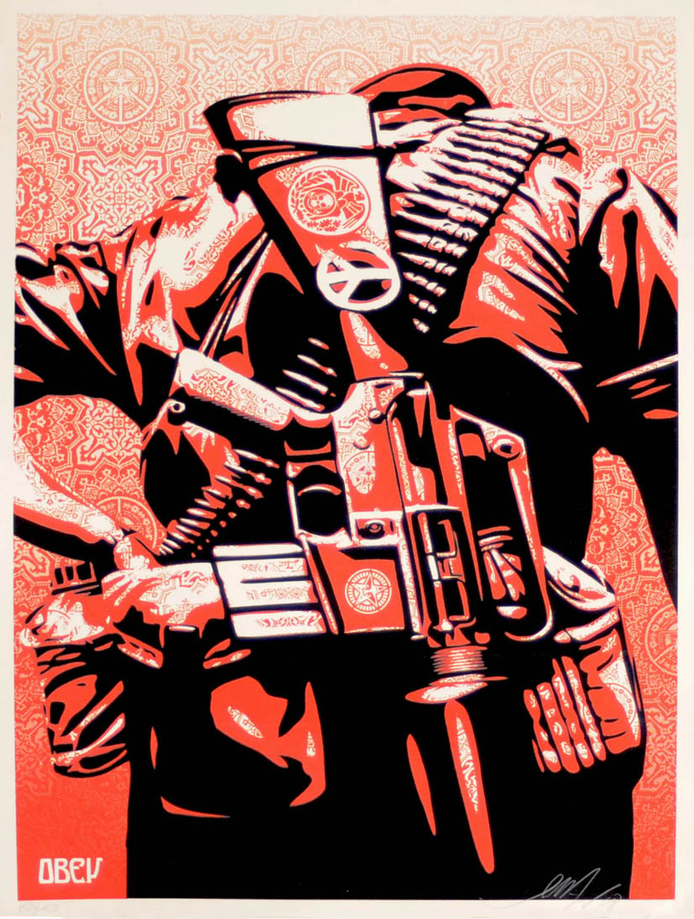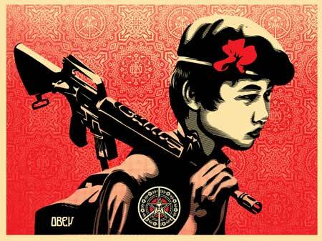
Shepard Fairey is the man many hail as the originator of the modern urban art scene and is an undeniable phenomenon. First coming to prominence in 1989 with his now ubiquitous 'Obey Giant' sticker campaign, the self styled phenomenologist has since gone on to become one of the most recognisable artists of the early 2000's.
His work, a mixture of parody and protest, serves to subvert the very medium to which it attaches itself. Wall paper posters adorn advertising billboards that in his own words 'market nothingness' while large scale posters with the simple one word message 'obey' stir the bewildered masses. His unique use of stencils, collage, photography and painting have led to collaborations with among others, DJ Shadow, Interpol, Smashing Pumpkins and more recently the poster art for the Johnny Cash biopic, 'Walk the Line'.
It was in 2008 that Shepard Fairey gained fame with the large public when he created, illegitimately, the now world over famous Obama Hope poster in red and blue colors. While this was not official promotion, Shepard Fairey claims that the Obama campaign did contact him to change the word PROGRESS, which was originally on the poster, to the word HOPE. Whilst they could not officially acknowledge the poster even there the campaign officials tries to make the most out of every initiative.
Since then everything has gone steep uphill for Fairey. He now displays in many museums of contemporary art and sells out his limited edition prints within minutes.
''If Shepard Fairey comes to your town, every single graffiti writer gets uptight. We don't like Shepard because he makes us feel scared and lazy. I am absolutely positive he has made more reaches than any graffiti writer in history ever has done or ever will. And that means he's won. Anyway, I once got to go gambling with his wife and she's very lucky'' - Banksy
ADD:
YOUR OPINION AND LINKS TO YOUR OWN WORK/IDEAS.

