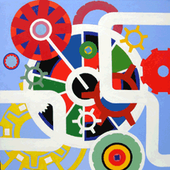
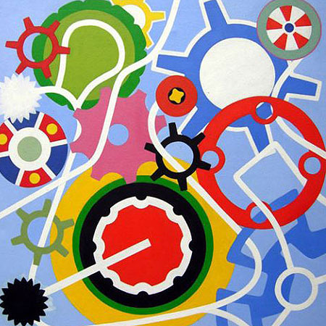
I am a studio artist exploring ideas using painting, collage and drawing.
Under the heading of ‘Existential Diagrams’, I am pursuing a train of thought that painting involves mapping of the self.
My practice is an intellectual and existential exercise, in processing and arranging information. This data is connected to my idea of external reality and seems to resonate metaphorically with something hidden inside myself.
I am following a desire to organize and compress different elements into an apparently effortless composition or design. if I am lucky, unexpected connections are made and there are brief moments of calm and wholeness.
To do this I work in the plan view, borrowing the format of the diagram. A diagram is a abstract universally recognized pictorial way of delivering detailed information or instructions. It conveys only the essence of the true meaning but hints at much more

