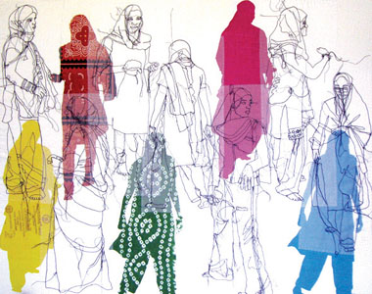
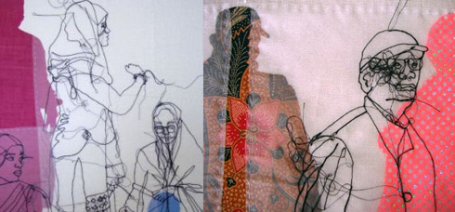
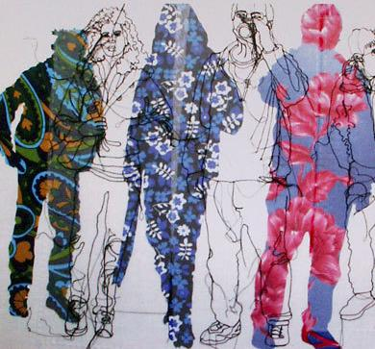
Rosie James is a current artist, based in Rochester, South East
I am a Textile Artist. My work focuses on drawing using the sewing machine, and hand embroidery. I also screen print elements. I am particularly interested in crowds, and the individual within the crowd.
Rosie James is based in Rochester, South East
I am a Textile Artist. My work focuses on drawing using the sewing machine, and hand embroidery. I also screen print elements. I am particularly interested in crowds, and the individual within the crowd.

