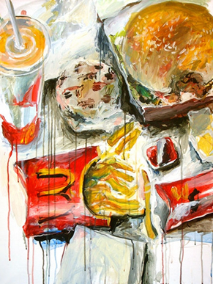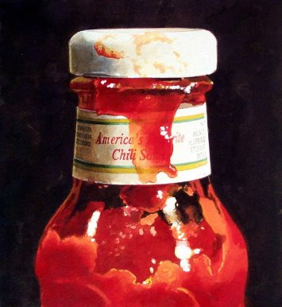
Vika – from Moskow – still alive.
Ralph goings –
Ralph Goings is a realist painter who has exhibited in this country, Europe and Japan and is represented in museums and private collections here and abroad. He is recognized as one of the original members of the Hyper-Realist or Photo-Realist group of the late 1960's.
This website is an overview of Goings work of the last forty years. It offers a sampling of early work from the 1960's and then, beginning with the pickup series, surveys the fast-food eateries, diner interiors and counter-top still life paintings of the 70's, 80's and 90's.
He has drawn our attention to the ordinary everyday experience of American life... showing that there is beauty in the mundane.
All works shown are in private collections or collection of the artist.
"My paintings are about light, about the way things look in their environment and especially about how things look painted.
Form, color and space are at the whim of reality, their discovery and organization is the assignment of the realist painter."

