Nancy Newman
“Those who continue to grow, despite their age, are always in a continuous state of gearing up for life’s next challenge. They maintain a forward momentum and are infectiously enthused about life, which is after all an adventure, not a guided tour.”
My challenge is to learn something new every day and to create a reflection of the small things in life which bring me joy and spark my imagination. As an educator I believe in and practise lifelong learning. Art keeps me enthused and allows my adventure to continue.

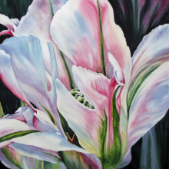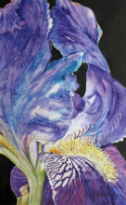
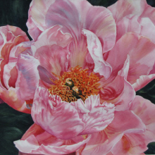
how does the artist lay out her page
how does she paint the flowers – technique, colour
Why do you think she uses this background?

what is your opinion?
how could this artist inspire you?

