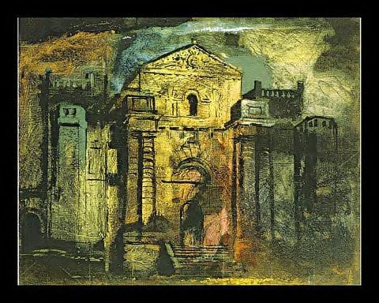
The baroque castle of Seaton Delaval, Northumberland, was built by John Vanbrugh between 1718 and 1729 and destroyed by fire in 1822. Piper visited the castle in 1941. He had previously made records of major buildings in anticipation of their destruction through bombing or modernisation. He had also recorded bomb-damage, and found parallels between the ruined castle and these recent subjects. The image seems to be both a nostalgic lament for a lost time and a statement about the present. Piper described the castle’s colouring as ‘ochre and flame licked red, pock-marked and stained... incredibly up-to-date: very much of our times’.

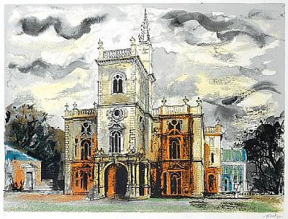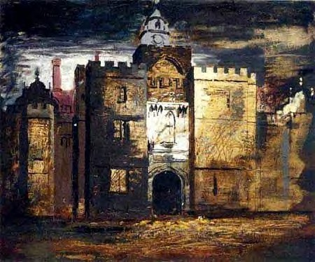

Painter of architecture, landscape and abstract compositions
Born 13 December 1903 died 1992 in the UK

Also add your observations of colour, composition, use of tone and shadows, links to your work and ideas.

