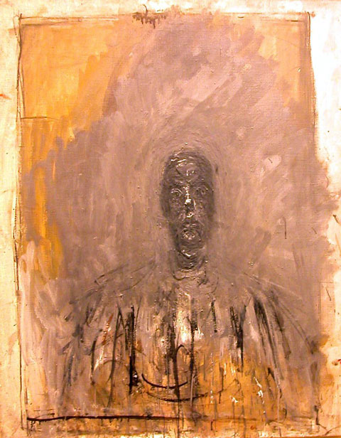
rubbed out surfaces and highly defined forms
His work looks unfinished like a painting in progress that he just walked away from for a moment.
Sketchy style links to your drawing ability, comment on this link! Also link to your colour scheme as it is similar.
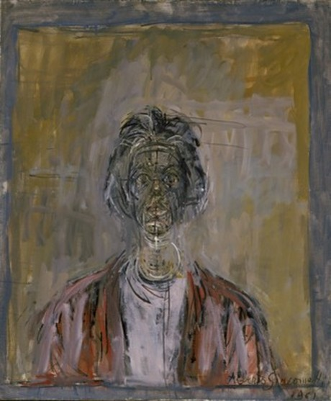
Alberto Giacometti 10 October 1901, died 11 January 1966, from Switzerland

