Frank Stella (born May 12, 1936) is an Italian American painter and printmaker, noted for his work in the areas of minimalism and post-painterly abstraction.
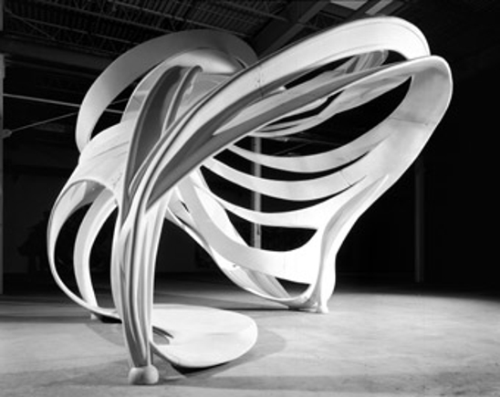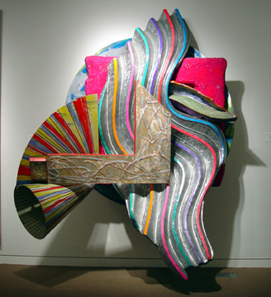
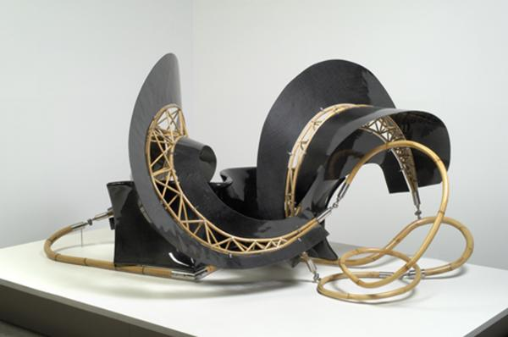
Frank Stella has had a long and varied career. He made his name in the 1950s with a series of all-black paintings, when that kind of thing was audacious; moved on to boldly colored striped canvasses by the 1960s; and in more recent decades, he’s used aluminum to make super-colorful, twisty, sci-fi-looking sculptures.
The whirling, extravagant lines resemble a mess of notes and figures, but with the measured specificity of Kandinsky’s studies, and a thoughtful approach to rhythm and movement. Stella “draws” with metal, creating small, handcrafted middles first before fleshing them out on a computer. His sculptural final pieces are sometimes brightly colored, sometimes technical, but always balanced. One piece, “K.54,” has organic elements resembling plant skeletons, while another, “K.51,” suggests an automobile engine fused with a giant bug. Each line seems to have a different tactile sense, where elegance is somehow combined with weight.
