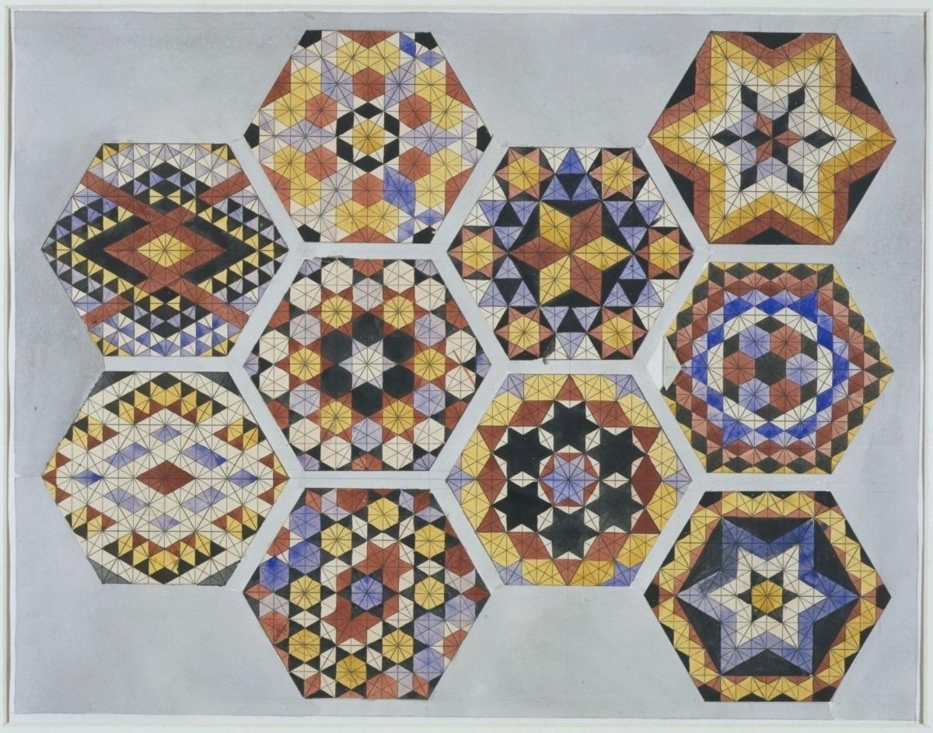
It looks pretty finicky and mechanical until you see it in detail:
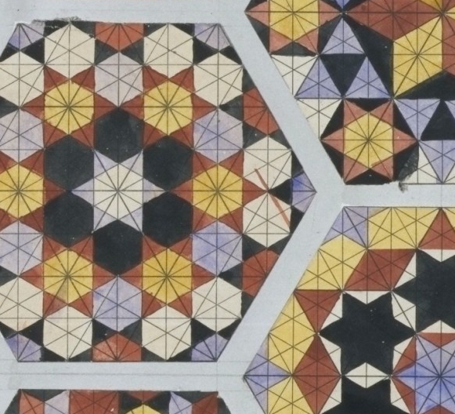
Up close you can see how handmade the drawing is, with its carefully ruled lines (including some for layout), and triangles and hexagons painstakingly but not always successfully filled-in with watercolour. You realize how difficult it was to arrive at the underlying logic of the geometry and then get it on to a page.
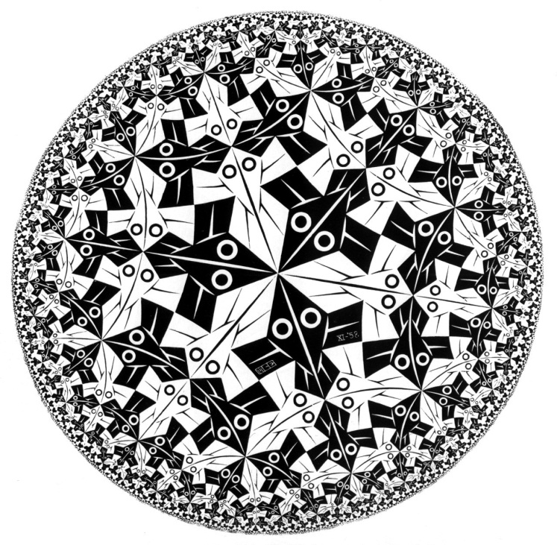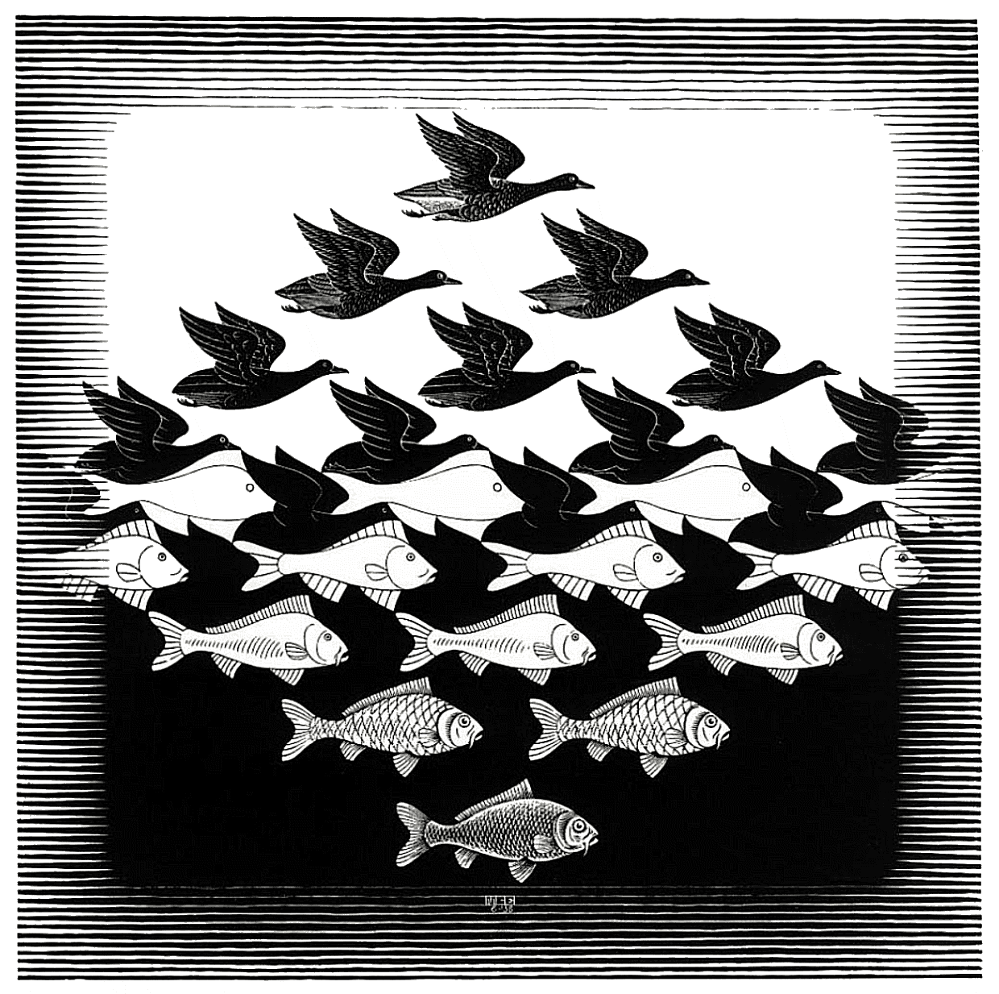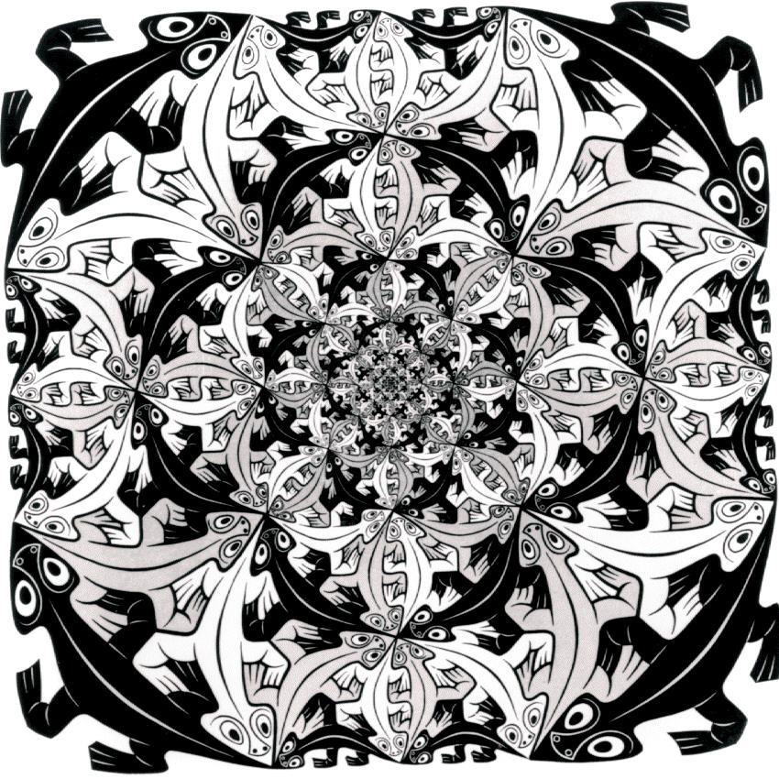
MC Escher
Escher's first print of an impossible reality was Still Life and Street, 1937. His artistic expression was created from images in his mind, rather than directly from observations and travels to other countries. Well known examples of his work include Drawing Hands, a work in which two hands are shown, each drawing the other; Sky and Water, in which light plays on shadow to morph the water background behind fish figures into bird figures on a sky background; and Ascending and Descending, in which lines of people ascend and descend stairs in an infinite loop, on a construction which is impossible to build and possible to draw only by taking advantage of quirks of perception and perspective.
He worked primarily in the media of lithographs and woodcuts, though the few mezzotints he made are considered to be masterpieces of the technique. In his graphic art, he portrayed mathematical relationships among shapes, figures and space. Additionally, he explored interlocking figures using black and white to enhance different dimensions. Integrated into his prints were mirror images of cones, spheres, cubes, rings and spirals. Escher was left-handed.^{[7]}
In addition to sketching landscape and nature in his early years, he also sketched insects, which frequently appeared in his later work. His first artistic work, completed in 1922, featured eight human heads divided in different planes. Later around 1924, he lost interest in "regular division" of planes, and turned to sketching landscapes in Italy with irregular perspectives that are impossible in natural form.

Although Escher did not have mathematical training—his understanding of mathematics was largely visual and intuitive—Escher's work had a strong mathematical component, and more than a few of the worlds which he drew are built around impossible objects such as the Necker cube and the Penrose triangle. Many of Escher's works employed repeated tilings called tessellations. Escher's artwork is especially well liked by mathematicians and scientists, who enjoy his use of polyhedra and geometric distortions. For example, in Gravity, multicolored turtles poke their heads out of a stellated dodecahedron.
The mathematical influence in his work emerged around 1936, when he was journeying the Mediterranean with the Adria Shipping Company. Specifically, he became interested in order and symmetry. Escher described his journey through the Mediterranean as "the richest source of inspiration I have ever tapped."
After his journey to the Alhambra, Escher tried to improve upon the art works of the Moors using geometric grids as the basis for his sketches, which he then overlaid with additional designs, mainly animals such as birds and lions.
His first study of mathematics, which later led to its incorporation into his art works, began with George Pólya's academic paper on plane symmetry groups sent to him by his brother Berend. This paper inspired him to learn the concept of the 17 wallpaper groups (plane symmetry groups). Using this mathematical concept, Escher created periodic tilings with 43 colored drawings of different types of symmetry. From this point on he developed a mathematical approach to expressions of symmetry in his art works. Starting in 1937, he created woodcuts using the concept of the 17 plane symmetry groups.
In 1941, Escher summarized his findings in a sketchbook, which he labeled Regelmatige vlakverdeling in asymmetrische congruente veelhoeken ("Regular division of the plane with asymmetric congruent polygons").^{[8]} His intention in writing this was to aid himself in integrating mathematics into art. Escher is considered a research mathematician of his time because of his documentation with this paper, in which he studied color based division, and developed a system of categorizing combinations of shape, color and symmetrical properties.
Around 1956, Escher explored the concept of representing infinity on a two-dimensional plane. Discussions with Canadian mathematician H.S.M. Coxeter inspired Escher's interest in hyperbolic tessellations, which are regular tilings of the hyperbolic plane. Escher's wood engravings Circle Limit I–IV demonstrate this concept. In 1959, Coxeter published his finding that these works were extraordinarily accurate: "Escher got it absolutely right to the millimeter."

