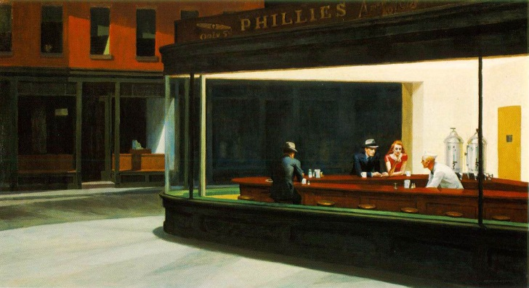
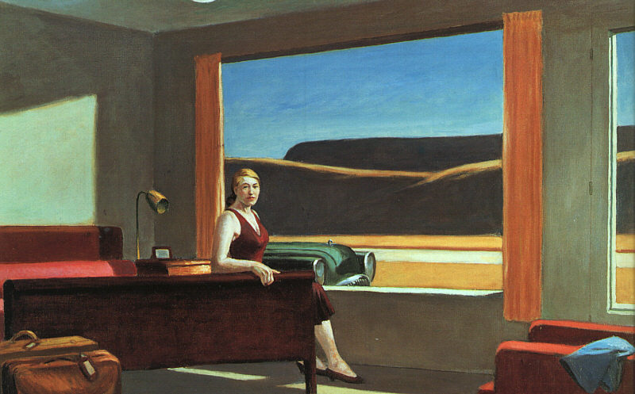
Edward Hopper (July 22, 1882 – May 15, 1967) was a prominent American realist painter and printmaker. While he was most popularly known for his oil paintings, he was equally proficient as a watercolorist and printmaker in etching. Both in his urban and rural scenes, his spare and finely calculated renderings reflected his personal vision of modern American life.

Include some of the above information, then the following for the higher marks:
- Your observations of the artist’s use of colour, materials, techniques etc.

- Your opinion of the work

- How they could inspire you

