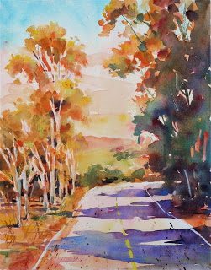

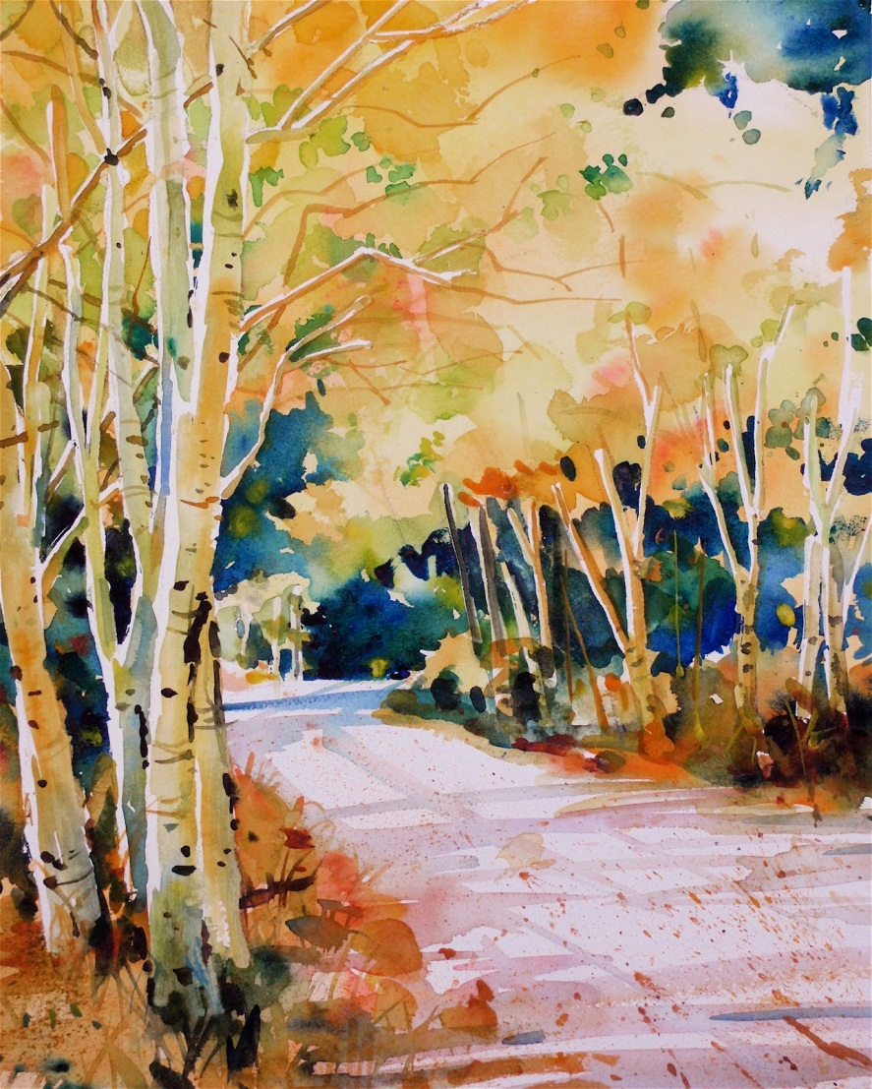
David Lobenberg
These are two 11 inch by 14 inch watercolour paintings I recently did for my watercolour class at The School of Light and Color in Fair Oaks Village, California. 'Eucalyptus Road ' has a soft early morning- like atmosphere while "Aspen Lane" has a more hard edge, crisp feel.
‘I used masking liquid to protect the tree trunks on the aspen as I was freely painting in the warm, Fall foliage. No masking was used on the eucalyptus trees, and I had to work carefully around the tree trunks. I also did my best to soften the edges of the foliage so that it blended in slightly with the sky. I think this helped to create a more diffused and softer early morning feel.’

