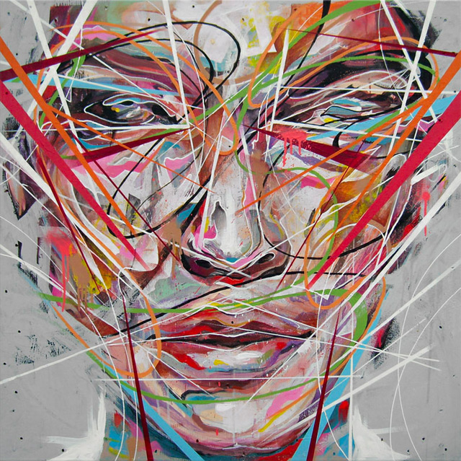
These vibrant paintings by artist Danny O’Conner are created using acrylic, spray paint, emulsion and correction fluid resulting in explosive portraits that seem to shatter and pulse off the canvas
