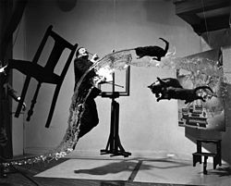
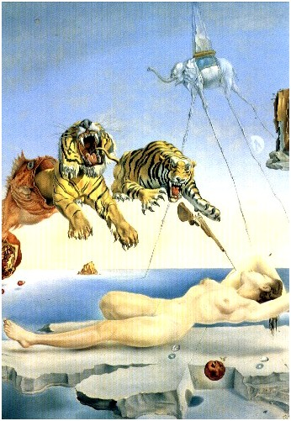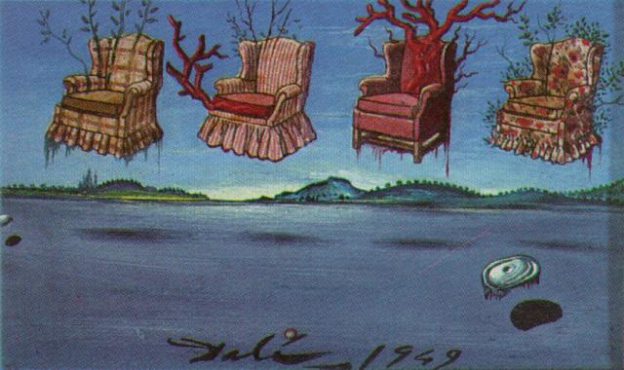
May 11, 1904 – January 23, 1989), known as Salvador Dalí (Catalan pronunciation: [səɫβəˈðo ðəˈɫi]), was a prominent Spanish surrealist painter
Salvador Dali is among the most versatile and prolific artists of the twentieth century. Though chiefly remembered for his painterly output, in the course of his long career he successfully turned to sculpture, printmaking, fashion, advertising, writing, and, perhaps most famously, filmmaking in his collaborations with Luis Bunuel and Alfred Hitchcock. Dali was renowned for his flamboyant personality as much as for his undeniable technical virtuosity. In his early use of organic morphology, his work bears the stamp of fellow Spaniards Pablo Picasso and Joan Miró. His paintings also evince a fascination for Classical and Renaissance art, clearly visible through his hyper-realistic style and religious symbolism of his later work. Dali is most often associated with the Surrealist movement, despite his formal expulsion from the group in 1934 for his reactionary political views.

