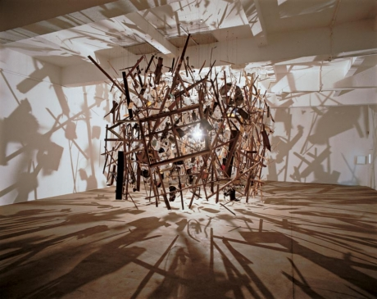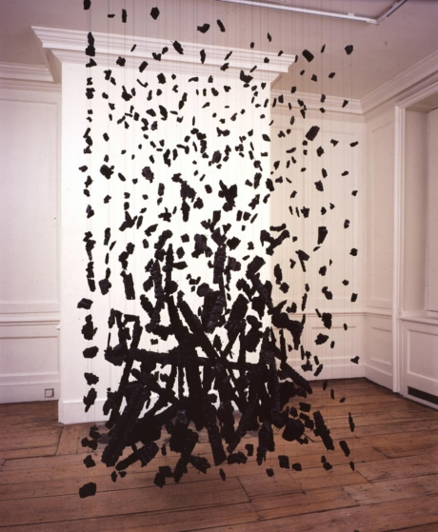
Cornelia parker born 1956, Cheshire, England
For some years Cornelia Parker’s work has been concerned with formalising things beyond our control, containing the volatile and making it into something that is quiet and contemplative like the ‘eye of the storm’. She is fascinated with processes in the world that mimic cartoon ‘deaths’ – steamrollering, shooting full of holes, falling from cliffs and explosions. Through a combination of visual and verbal allusions her work triggers cultural metaphors and personal associations, which allow the viewer to witness the transformation of the most ordinary objects into something compelling and extraordinary.
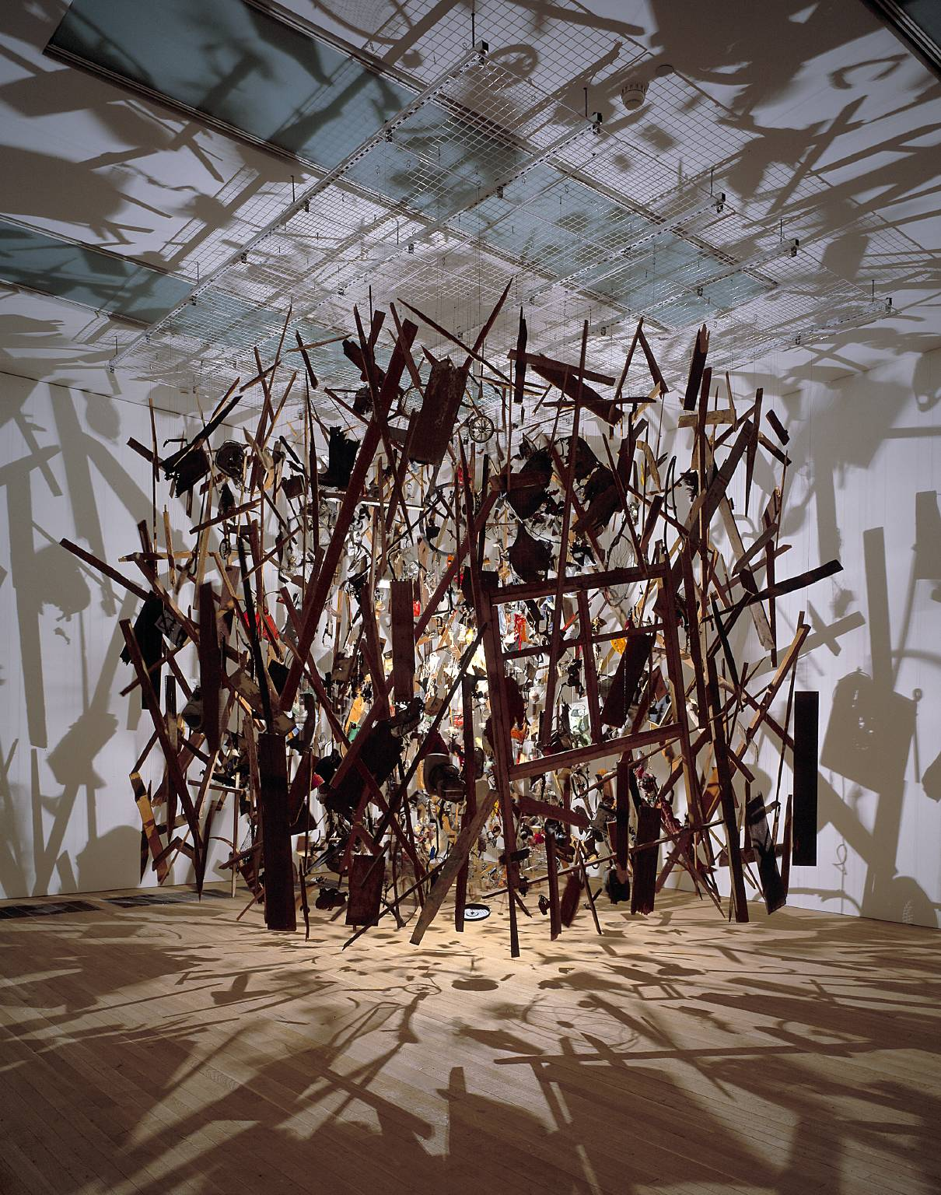
http://www.frithstreetgallery.com/artists/bio/cornelia_parker/?/parker.html
Artist
Cornelia Parker(born 1956)
Title
Cold Dark Matter: An Exploded View
Date 1991
MediumWood, metal, plastic, ceramic, paper, textile and wire

We begin with an explosion; a common garden shed exploded into hundreds of shards, fragments, particles. And, after this explosion, there follows a careful process of arrangement where each fragment is attached to wire and suspended within a gallery space. The shards are gathered around a single light bulb that has been found intact among the debris that the explosion has left in its wake. The creation of Parker’s Cold Dark Matter: An Exploded View is a choreographic, almost photographic act, an assisted readymade that speaks of an event by which waste has been created – a waste, a remnant, a remainder of action caught in an unreal time that is neither fabricated nor factual, present nor absent. These objects have been retained and displayed to unfold this weird and wired tableau that, despite its apparent inertia, demands that we follow the course of things through a process of creative destruction. On the gallery wall a small piece of text tells us that Parker had taken a garden shed to the British army and, with the help of some explosives, dispensed with this rather diminutive yet functional piece of garden architecture. The work’s subtitle, ‘An Exploded View’, helps us to trace the relationship between the artwork that is suspended before us and the creative work of destruction that the art required.
Remember to give:
Your own observations, opinion and how it links/could inspire your ideas.

