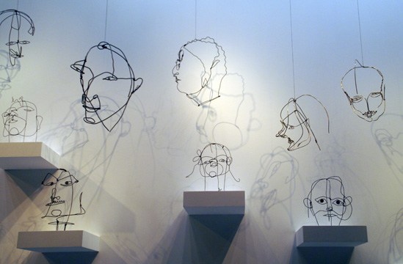
Alexander Calder (1898-1976), whose illustrious career spanned much of the 20th century, is the most acclaimed and influential sculptor of our time. Born in a family of celebrated, though more classically trained artists, Calder utilized his innovative genius to profoundly change the course of modern art. He began by developing a new method of sculpting: by bending and twisting wire, he essentially "drew" three-dimensional figures in space. He is renowned for the invention of the mobile, whose suspended, abstract elements move and balance in changing harmony. Calder also devoted himself to making outdoor sculpture on a grand scale from bolted sheet steel. Today, these stately titans grace public plazas in cities throughout the world.

Give: your observations of his style, technique and your opinion. How it links to your work.

