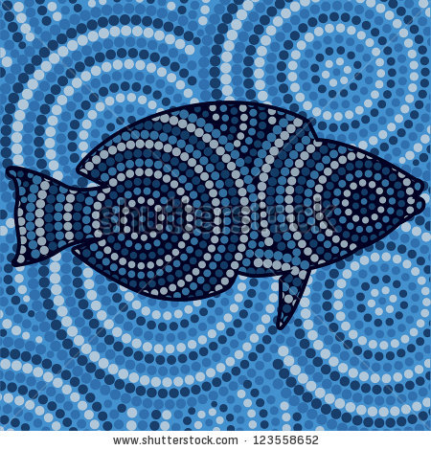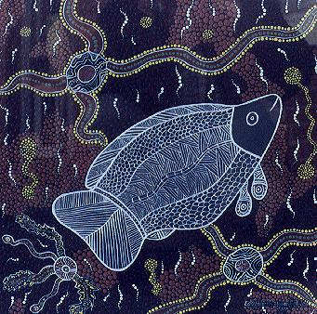
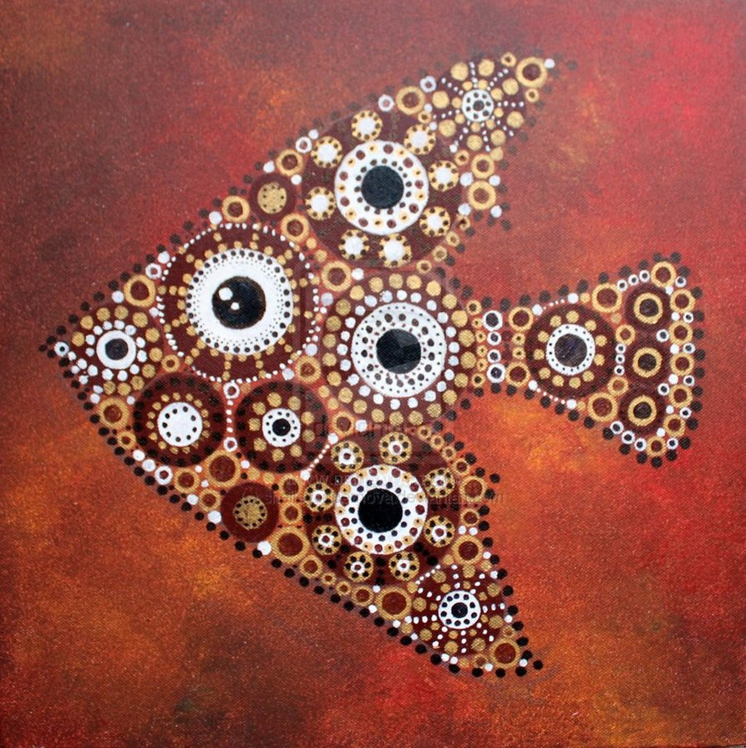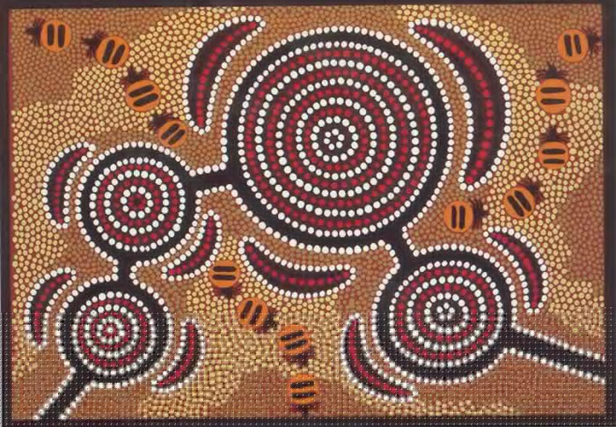
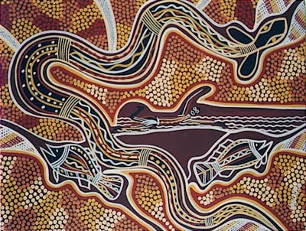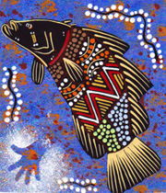
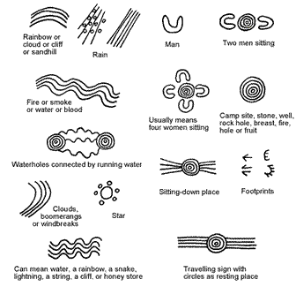
Aboriginal Art
Aboriginal art is a type of art native to the Australian Aboriginals. Traditional Aboriginal art was inspired by religious ceremonies or rituals.
Aboriginal art is an important part of the world's oldest continuous cultural tradition. It is also one of the most interesting areas of art. It is based on totems and the Dreaming. All the designs, painted or drawn, have a story behind them.
Symbols are used in Aboriginal art, to show the presence of different things. For example, a 'U' shape is the symbol for a man. Aboriginal art is a language in itself, communicating through beautiful patterns. This started around 30,000 to 40,000 years ago.

